**Trend News**

*A*

***Synopsis/Project Report***

*Submitted*

*in partial fulfillment*

*for the award of the Degree of*

***Bachelor of Computer Application***

***in Department of C.A. & I.T.***

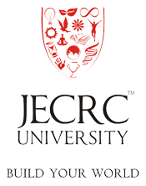

**Submitted to: Mr. Abhishek Sharma Submitted By: Ritik Jain (1405011048)**

**Department of C.A. & I.T.**

School of Engineering

JECRC University

**January-June 2016**